Gmail – Google Drive Instructions
Gmail for St. Mike’s employees:
- Email Chris North at cnorth@champlain.edu and tell him you need a GMHEC email account for Project Ensemble.
- When your account is set up turn on Two Factor Authentication by clicking on this link and following these instructions – you’ll need your cell phone with you
- Automatically forward all emails that will go to this new gmail account to your regular work email
  - https://support.google.com/mail/answer/10957?hl=en
- Automatically delete the emails in the gmail account after they were forwarded
  - Go to settings
  - Go to “Forwarding and POP/IMAP”
  - Change “keep Gmail’s copy in the Inbox”
  - To “delete Gmail’s copy”
  - Click on “save changes” on bottom of screen
Google Docs for Middlebury employees:
- For Middlebury employees:
  - How to log in (everybody has a Google docs account)
  - https://mediawiki.middlebury.edu/wiki/LIS/Google_Apps#How_do_I_log_in.3F
- For Saint Mike’s employees:
  - Go to www.drive.google.com
  - Use the same username/password as for the Gmail account you set up
  - Or go from your Gmail account or just to google.com and click on the 9 dot square on the upper right side and choose “Drive”
- How to Save a shared folder or document that was shared with you to easily find the documents again
  - Click on the link to the folder or document in your email
  - The folder will open in your google drive (if you have google for personal as well make sure it’s opening in your work google drive)
  - Right-Click on the folder name next to “My Drive” in the picture example below right-click on “Benefits”
  - 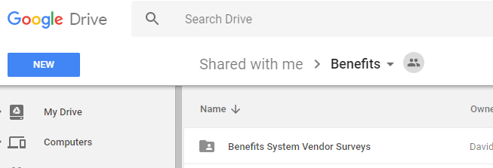
  - Click on “Add to my Drive”
  - From now on when you go into google docs the folder will show up under “My Drive”

